­A Project Report on

#### **Market Analysis based on Social network**

Submitted in partial fulfillment of requirement

for the award of the degree

##### **MASTER of COMPUTER APPLICATIONS**

Of

###### Visvesvaraya Technological University

By

###### **Abhijith B. S. – [1PI13MCA01]**

###### **Joshua Fernandes- [1PI13MCA31]**



PES INSTITUTE OF TECHNOLOGY

100 Ft Ring Road, B.S.K 3rd Stage, Bangalore-85

**2015**

**PES INSTITUTE OF TECHNOLOGY**

**Department of MCA**

**100 Ft Ring Road, BSK 3rd Stage**

**Bangalore 85**

**2015**



**C E R T I F I C A T E**

This is to certify that the project entitled **“Market analysis based on Social network”** is a bonafide work carried out by **Abhijith B.S. [1PI13MCA01]** submitted in partial fulfillment of the requirement of Fourth semester course work of MCA during the academic session Jan-May 2015.

**Ms. Deepthi S Narayan Dr. Neelam Bawane**

Assistant Professor, Professor & Head

Department of MCA Department of MCA PES Institute of Technology PES Institute of Technology Bangalore Bangalore

**Examiners**

**1.**

**2**

**DECLARATION**

I, **Abhijith B. S.**, student of 5th MCA, **PESIT** bearing USN **1PI13MCA01** hereby declare that the project entitled **“Market analysis based on Social network”** has been carried out by me under the supervision of Guide (Co-guide) **Mrs. Deepthi S Narayan,** Assistant Professor, and submitted in partial fulfillment of the requirement for the award of the Degree of Master Of Computer Application by the **Visvesvaraya Technological University** during the academic year 2015. This report has not been submitted to any other Organization/University of any award of degree or certificate.

Name:

Signature:

**ACKNOWLEDGEMENT**

We take this opportunity to express my profound sense of sincere and deep gratitude to all those who have contributed to the knowledge and experience that I have gained during my project work.

To begin with, I express my heartfelt gratitude to **Dr. K.S. Sridhar**, Principal, PES Institute of Technology, Bangalore for providing me an opportunity to take up this project.

I would also like to express my heartfelt thanks and regards to **Dr. Neelam Bawane**, Head of the Department of MCA, PES Institute of Technology, Bangalore, for her overwhelming support in my project.

I extend my profound gratitude to the project guide**, Ms Deepthi S Narayan**, Assistant Professor, Department of MCA, PES Institute of Technology, Bangalore for her valuable guidance, co-operation and suggestions and also his encouragement to complete this project.

Finally, I would like to thank my friends for all their support and encouragement during my project work.

**ABSTRACT**

The **MASK project** will allow users to generate an automated report on any keyword/brand name presented based on real –time social media. It will provide in-depth analysis and cluster the information available on social media giving the users graphical and statistical data of their product/brand name of interest. The project will aggregate the information which will be provided by the users allowing them to view previous and current analysis of their keywords.

The applications of this project would be Market analysis for products, brands with the data sourced from Social network like twitter, provides real time analysis of the product and brands and presents various information which could aid in decision making.

Table of Contents

1. INTRODUCTION 1

1.1 Purpose 1

1.2 Product Perspective 1

1.3 Product Functions 1

1.4 User Classes and Characteristics 1

2. LITERATURE SURVEY 2

2.1 Existing System 2

2.2 Proposed System 2

3. REQUIREMENTS ANALYSIS 3

3.1 Operating Environment 3

3.2 Design and Implementation Constraints 3

3.3 User Documentation 3

3.4 Assumptions and Dependencies 3

4. SOFTWARE REQUIREMENTS SPECIFICATION 4

4.1 Users 4

4.1.1 End-user 4

4.2 Functional Requirements 4

4.2.1 Ability for the end-user to perform sentimental analysis on their product. 4

4.2.2 The end-user should be able to generate word cloud for his product 4

4.2.3 The system should provide user to compare two brands. 4

4.2.4 The system should display the best and the worst tweets for each sentimental report generated. 4

4.3 Non- Functional Requirements 4

4.3.1 Performance Requirements 4

4.3.2 Safety Requirements 5

4.3.3 Security Requirements 5

4.3.4 Software Quality Attributes 5

4.4 Software and Hardware Requirement 5

*4.4.1* Hardware Interface 5

4.4.2 Software Interfaces 6

4.4.3 Communications Interfaces 6

5. ANALYSIS AND DESIGN 7

5.1 Use Case 7

5.2 Sequence Diagram 8

5.3 Activity Diagram 9

5.4 ER Diagram 10

5.5 Data Dictionary 10

6. IMPELEMENTATION 12

6.1 Screen Shots 12

7. SOFTWARE TESTING 16

7.1 Testing Objectives: 16

7.2 Testing Principles: 16

7.3 Unit testing: 16

7.4 Test Cases: 16

7.4.1 Login Page 16

7.4.2 User creation 17

7.4.3 Sentimental Search 17

7.4.4 Word Cloud 18

7.4.5 Brand comparison 18

8. CONCLUSION 19

9. FUTURE ENHANCEMENTS 20

10. BIBLIOGRAPHY 21

Table of Figures

Figure 1Mask Use Case 7

Figure 2 Sequence Diagram 8

Figure 3Activity Diagram 9

Figure 4 ER diagram 10

Figure 5 Login Page 12

Figure 6Sign Up Page 12

Figure 7 Enter Hashtag 13

Figure 8 Display sentimental analysis 13

Figure 9 Display previous sentments 14

Figure 10 Display Word Cloud 14

Figure 11 Display previous word cloud 15

Figure 12 Show comparisons 15

# INTRODUCTION

## Purpose

The Market Analysis based on Social network serves the purpose of mining real-time information from social networks and to analyze the data to provide useful information to the end-user who is interested in getting to know the influence of his product or brand on the people and to help them make judgments or to streamline their product to achieve success in this ever changing world.

## Product Perspective

The product to be developed is a first of its kind, created with a idea of providing a quick and informative insights about a product by analyzing tweets from the Twitter.com using various technologies to make it possible.

This product is a self-contained and can be extended further to provided new services.

This SRS describes the requirements of the system as a whole and each of the services provided by the product.

It also lists the interfaces to be implemented and their inter-connections.

## Product Functions

It will be driven by three functionalities;

1. **Sentimental Analysis**: it performs a sentimental analysis of the tweets relating to the given keyword/product/brand and display the result in a graphical charts to better understand the sentimental influence of the product.
2. **Word Cloud**: it provide a insights about other products, brand names associated with the given product, it performs a association analysis and displays the result in a Word-Cloud format.
3. **Brand Comparison**: it provides the service of comparing 2 brands side by side to help the end-use to understand where their product stands against another in gaining influence in the social media.
4. The product also stores previous analysis information and provides the same as to help the end-use to understand how their product’s influence has changed.

## User Classes and Characteristics

**End-user:-** This type of user will be able to sign-up or login and use the features provided by the product and the information accessed by this user will be stored in Database for future use

# LITERATURE SURVEY

## Existing System

The current existing system just provide you a sentimental analysis but with does not provide any info-graphics which will renders the information not much useful.

There aren’t any product available in the market which provides a word-Cloud analysis and brand comparison from twitter data which are important features and useful tools for business to make better judgments.

## Proposed System

The proposed system MASK provides all the tools which are missing in the current existing system along with interactive graphics to provide a better UI experience to the end-user.

It also stores information of previous session/searches to enable the user to have a timeline which gives an excellent way to understand the progress of his/her product/service.

It will be able to serve huge amount of users to enable them to analyze their product with real time data from Twitters Big-data database with just a click away.

It provides start-ups and services to analyze their product and streamline their product/service as to meet their user expectations.

It allows them to view the bad and the good tweets about their product/service and serves as a feedback system to their product.

# REQUIREMENTS ANALYSIS

## Operating Environment

Apache Server, Linux OS, MySQL DB

## Design and Implementation Constraints

1. GUI is only in English.
2. Login and password is used for the identification of users.
3. Only registered users can use the service, if not registered, can sign-up in a minute.
4. Currently its Web-only accessible.
5. Limited to HTTP/HTTPS.
6. This system works on single server.

## 

## User Documentation

The Documentation of the project and the manual will be provided with the software along with the deployment.

## 

## Assumptions and Dependencies

The project assumes that the user has some knowledge of social media like twitter and how it influences the real world.

The project depends on the Apache server and the server up time to make the resource available 99.9%

# SOFTWARE REQUIREMENTS SPECIFICATION

## Users

### End-user

This type of user will be able to sign-up or login and use the features provided by the product and the information accessed by this user will be stored in Database for future use.

## Functional Requirements

### Ability for the end-user to perform sentimental analysis on their product.

The end-user will be able to perform a sentimental analysis on their product, where the system fetches the tweets from twitter and performs analysis on each tweet and plots the graph.

### The end-user should be able to generate word cloud for his product

The word cloud should be generated for the given product and displayed to the user and stores in database for future use, the previous stored on is overwritten .

### **The system should provide user to compare two brands.**

The user should be able to enter the brand names and generate a graphical report comparing the brands with the real time twitter data .

### The system should display the best and the worst tweets for each sentimental report generated.

It should also store the previous tweets and display along with the current one to give the user a preview about the best and worst tweets .

## Non- Functional Requirements

### Performance Requirements

(1) Static numerical requirements:

        (a)  The number of terminals to be supported: 20+

        (b)  The number of simultaneous users to be supported: 20+

        (c)  Number of files and records to be handled: 10

        (d)  Sizes of tables and files: 100GB

(2)  The numbers of transactions and tasks will be 5 per second and 95% of the transactions shall be processed in less than 1 s on a normal workload conditions and the numbers of transactions and tasks will be 20 per second and 95% of the transactions shall be processed in less than 5 s on a peak workload conditions

### Safety Requirements

Data will be transmitted with the use HTTP protocols and use inbuilt browser security measures.

### Security Requirements

Users will be authenticated based on provided login details.

### Software Quality Attributes

**Availability**

Is available anywhere throughout the world. Will display a 404 page in case of loss of connection. No data will be lost and no commits will be made until complete transaction is made to the server.

**Usability**

The system is easy to handle and navigates in the most expected way with no delays. The system program reacts accordingly and transverses quickly between its states.

## Software and Hardware Requirement

### Hardware Interface

|  |  |  |  |
| --- | --- | --- | --- |
| **Client Side** | | | |
|  | Processor | RAM | Disk Space |
| **Internet Explorer – 6 or above** | All Intel or AMD - 1 GHZ | 256 MB | 100 MB |

|  |  |  |  |
| --- | --- | --- | --- |
| **ServerSide** | | | |
|  | Processor | RAM | Disk Space |
| **Apache Server** | All Intel or AMD - 2 GHZ | 2GB | 100 GB |
| **MySql** | 512 MB | 500MB(Excluding Data Size) |

### 

### Software Interfaces

**Client on Internet**

Web Browser, Operating System (any)

**Client on Intranet**

Web Browser, Operating System (any)

**Web Server**

Apache (WAMP), Operating System (any)

**Data Base Server**

MySQL, Operating System (any)

**Development End**

LAMP (Linux, Apache, HTML, XML, PHP), MySQL, OS (Windows),

### Communications Interfaces

1. It uses the any Modern Web browser capable of running Java-script on client side.

2. It makes use of HTTP Protocol.

# ANALYSIS AND DESIGN

## Use Case

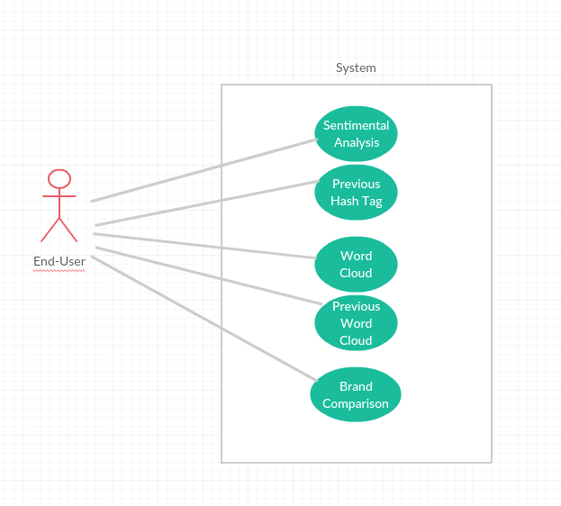

Figure 1Mask Use Case

# Sequence Diagram

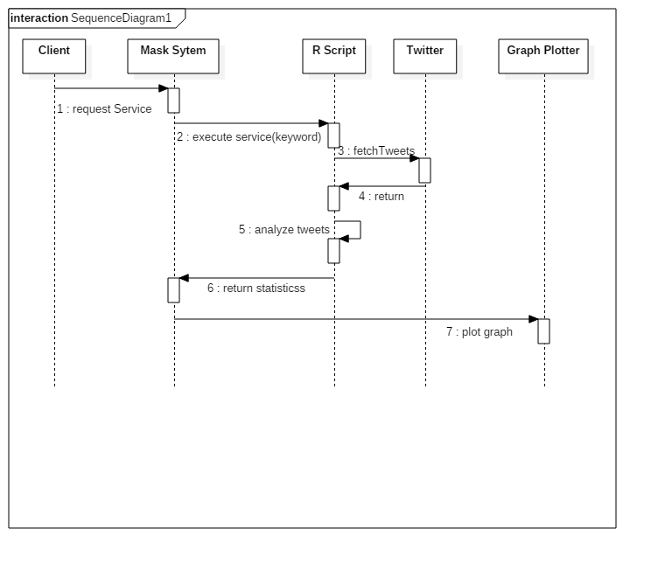

Figure 2 Sequence Diagram

## Activity Diagram

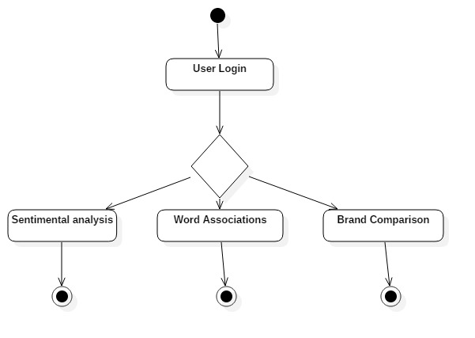

Figure 3Activity Diagram

## ER Diagram

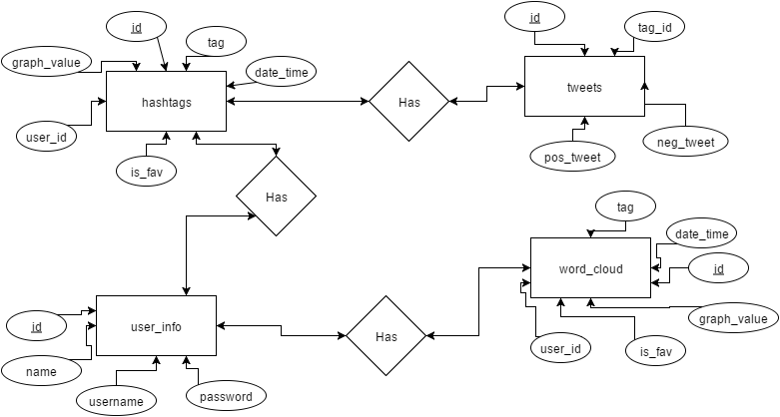

Figure 4 ER diagram

## Data Dictionary

**hashtags**

|  |  |  |
| --- | --- | --- |
| **Name** | **Data type** | **Comment** |
| Id | int(3) | Primary Key |
| Tag | Varchar(50) |  |
| Date_time | Date |  |
| Graph_values | varchar(500) |  |
| User_id | int(3) |  |
| Is_fav | int(2) |  |

**Tweet**

|  |  |  |
| --- | --- | --- |
| **Name** | **Data type** | **Comment** |
| Id | int(11) | Primary Key |
| Neg_tweet | varchar(100) |  |
| Pos_tweet | varchar(100) |  |
| Tag_id | int(3) |  |

**Word_cloud**

|  |  |  |
| --- | --- | --- |
| **Name** | **Data type** | **Comment** |
| Id | int(3) | Primary Key |
| Tag | Varchar(50) |  |
| Date_time | Date |  |
| Source_location | varchar(500) |  |
| User_id | int(3) |  |
| Is_fav | int(2) |  |

**User_info**

|  |  |  |
| --- | --- | --- |
| **Name** | **Data type** | **Comment** |
| Id | int(11) | Primary Key |
| Username | varchar(30) | Unique |
| Password | varchar(18) |  |
| Name | varchar(30) |  |

# IMPELEMENTATION

## Screen Shots

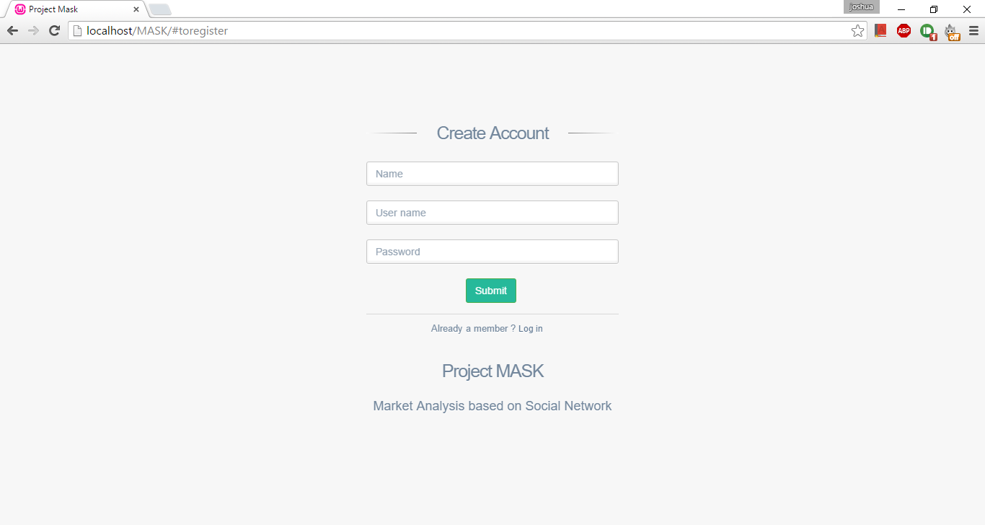

Figure 5 Login Page

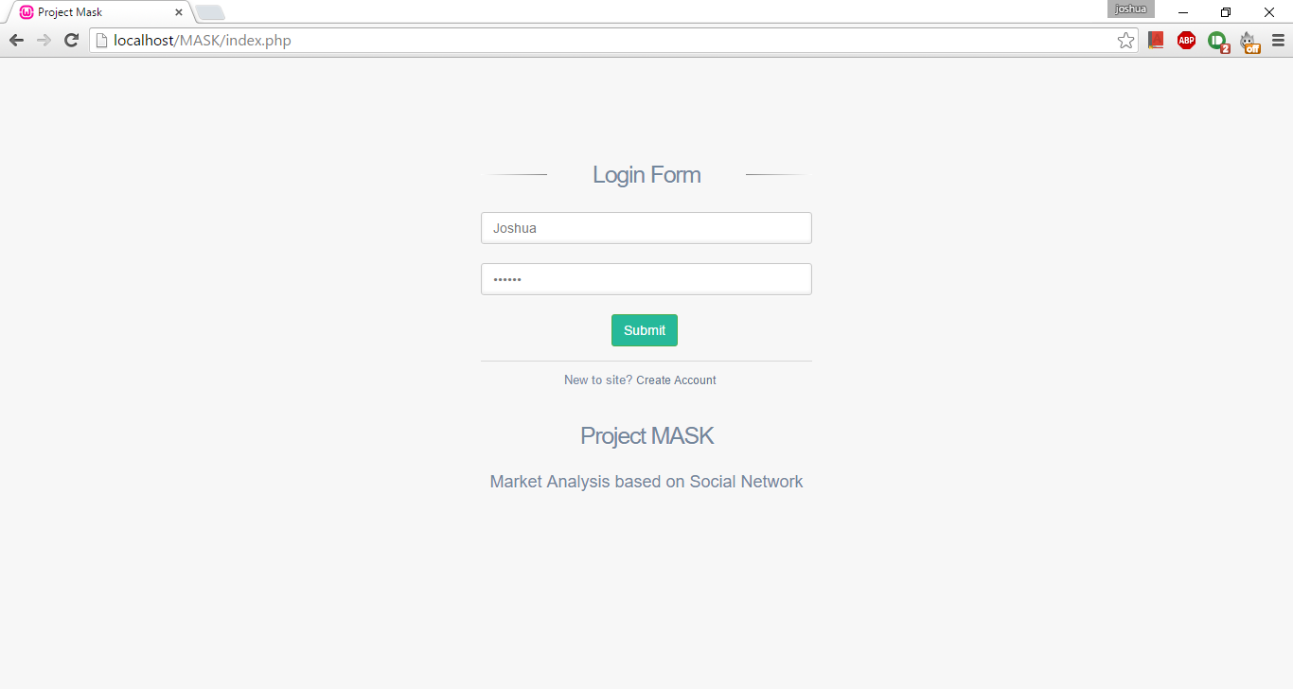

Figure 6Sign Up Page

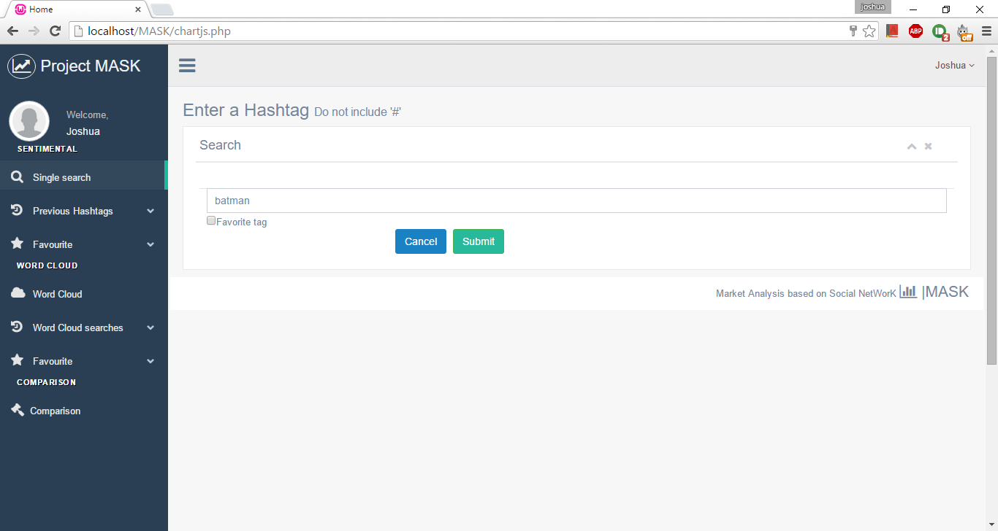

Figure 7 Enter Hashtag

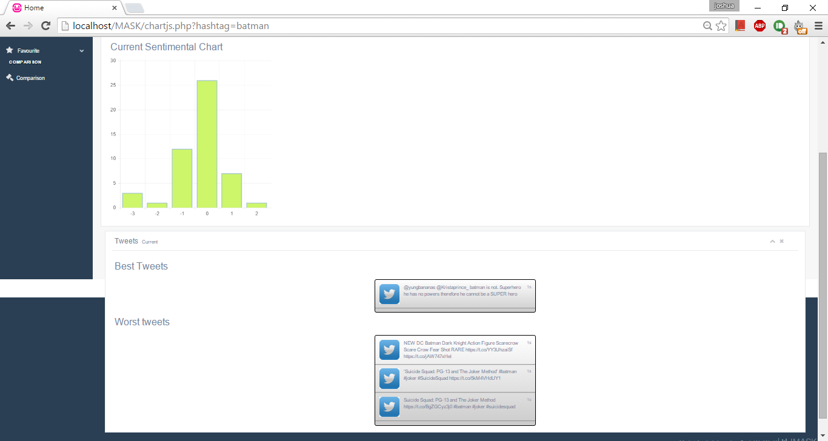

Figure 8 Display sentimental analysis

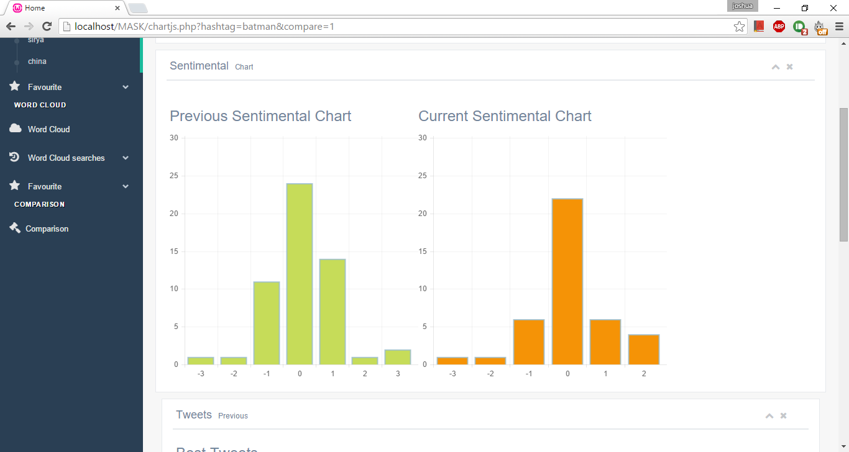

Figure 9 Display previous sentments

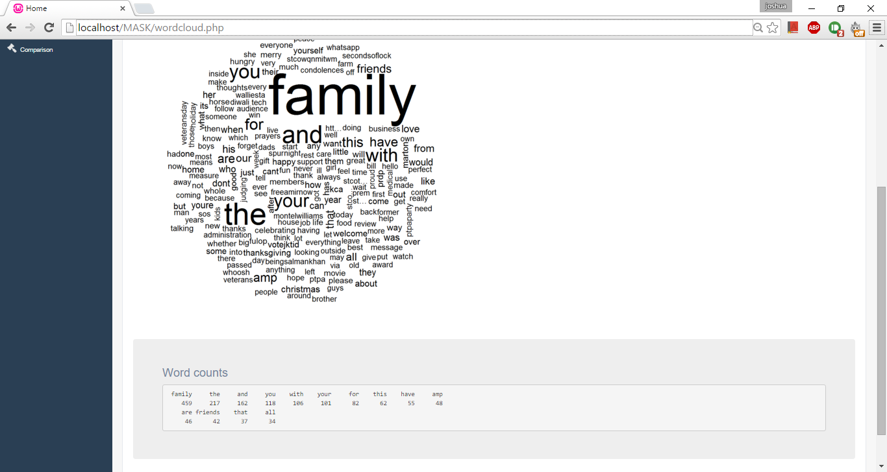

Figure 10 Display Word Cloud

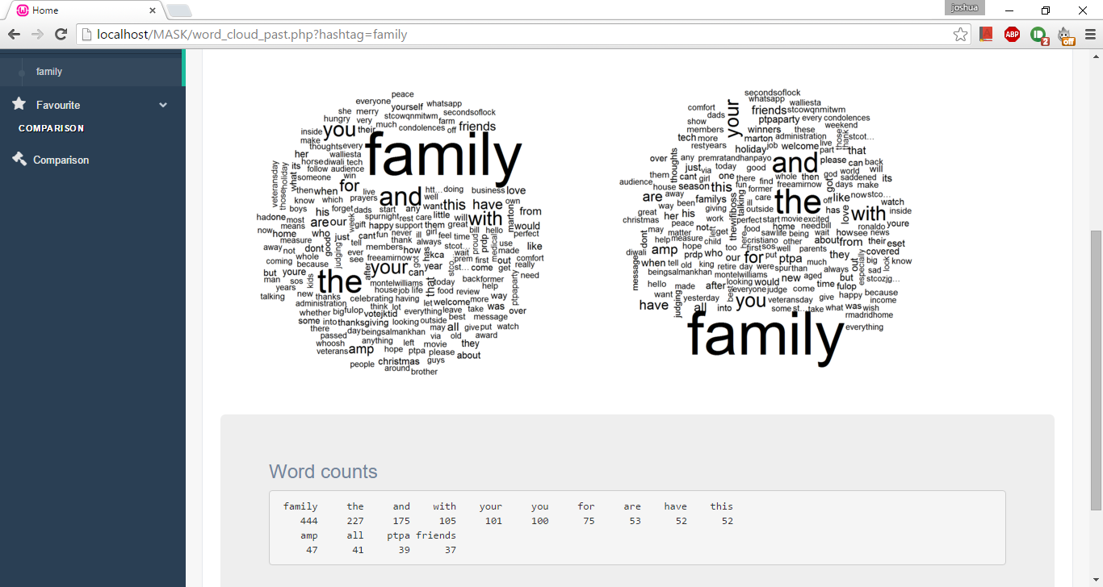

Figure 11 Display previous word cloud

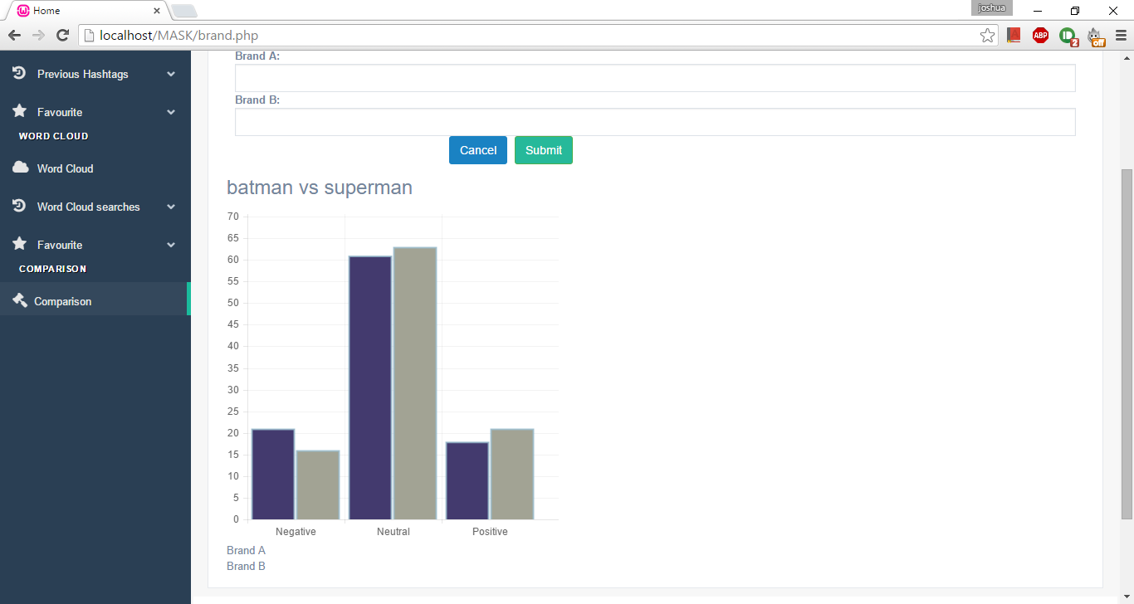

Figure 12 Show comparisons

# SOFTWARE TESTING

## Testing Objectives:

Testing is the execution an application with the goal of finding an error. A good test case runs multiple tests to find various errors and bugs in the system. A successful test is one that uncovers an unknown error.

## Testing Principles:

* All tests should follow the user requirements
* We should plan long before testing begins
* Testing should start with small modules and move onto the whole application.

## Unit testing:

It is the method of testing during the coding phase. It is uses the requirement document to test the modules one by one and revel an inaccuracies in the code and application.

## Test Cases:

### Login Page

|  |  |  |  |  |  |
| --- | --- | --- | --- | --- | --- |
| **S.NO.** | **Test** | **User Input** | **Expected Result** | **Actual Result** | **Status** |
| 1 | Check login | Valid username and invalid password | Print “Incorrect Password” | Set’s placeholder of password an invalid | Pass |
| 2 | Invalid username | Print “Invalid username” | Sets placeholder of username as invalid | Pass |
| 3 | Invalid Password | Print “Invalid Password” | Sets placeholder of password as invalid | Pass |

### User creation

|  |  |  |  |  |  |
| --- | --- | --- | --- | --- | --- |
| **S.NO.** | **Test** | **User Input** | **Expected Result** | **Actual Result** | **Status** |
| 1. | Check User sign up. | Null name or only space is provided | Print “Enter a name” | Java alert “Enter a valid name” | Pass |
| 2 | Invalid name(special characters) | Prints “Invalid name” | Java alert “Enter a Valid name” | Pass |
| 3 | Null username | Print “Enter a user name” | Java alert “Enter a valid user name” | Pass |
| 4 | Null Password | Print “Enter a Password” | Java alert “Enter a Password” | Pass |
| 5 | Password length less than 8 | Print “Password is too short” | Java alert “Please Enter a password with 8 Characters” | Pass |
| 6 | Null repeat Password | Print “Enter the repeat Password” | Java alert “Enter the repeat Password” | Pass |
| 7 | Repeat password does not match | Print “Passwords do not match” | Java Alert ”Passwords do not match” | Pass |

### Sentimental Search

|  |  |  |  |  |  |
| --- | --- | --- | --- | --- | --- |
| **S.NO.** | **Test** | **User Input** | **Expected Result** | **Actual Result** | **Status** |
| 1. | Check hashtag form input | Null hashtag | Print “Input hashtag” | Java alert “Enter a hashtag” | Pass |
| 2 | hashtag with special characters | Print “Invalid hashtag ” | Java alert “Enter valid hashtag” | Pass |
| 3 | Hashtag with space in between | Print “Input valid hashtag name” | Java alert “Enter a valid hashtag name” | Pass |

### Word Cloud

|  |  |  |  |  |  |
| --- | --- | --- | --- | --- | --- |
| **S.NO.** | **Test** | **User Input** | **Expected Result** | **Actual Result** | **Status** |
| 1. | Check hashtag form input | Null hashtag | Print “Input hashtag” | Java alert “Enter a hashtag” | Pass |
| 2 | hashtag with special characters | Print “Invalid hashtag ” | Java alert “Enter valid hashtag” | Pass |
| 3 | Hashtag with space in between | Print “Input valid hashtag name” | Java alert “Enter a valid hashtag name” | Pass |

### Brand comparison

|  |  |  |  |  |  |
| --- | --- | --- | --- | --- | --- |
| **S.NO.** | **Test** | **User Input** | **Expected Result** | **Actual Result** | **Status** |
| 1. | Check two hashtag form input | Null hashtag in textbox1 | Print “Input hashtag” | Java alert “Enter a hashtag” | Pass |
| 2 | hashtag with special characters in textbox1 | Print “Invalid hashtag ” | Java alert “Enter valid hashtag” | Pass |
| 3 | Hashtag with space in between in textbox1 | Print “Input valid hashtag name” | Java alert “Enter a valid hashtag name” | Pass |
| 4 | Null hashtag in textbox1 | Print “Input hashtag” | Java alert “Enter a hashtag” | Pass |
| 5 | hashtag with special characters in textbox1 | Print “Invalid hashtag ” | Java alert “Enter valid hashtag” | Pass |
| 6 | Hashtag with space in between in textbox1 | Print “Input valid hashtag name” | Java alert “Enter a valid hashtag name” | Pass |
| 7 | Hashtag in textbox1 and textbox2 are different. | Print ”Please do not enter the same hashtag in both inputs” | Java alert “Please do not enter the same hashtag in both inputs” | Pass |

# CONCLUSION

The foundation idea of the project was to provide a convenient and unpretentious platform for users to analyze any keyword/product/brand name based on social media, using an online interface to share real time information about the current influence of the same. This project also identifies key words associated with said keyword/product/brand name based on the number of frequent words tweeted by various users.

This project uses data mining and data visualization techniques to provide a graphical informational tool for users using bar charts and word clouds.

This project “Market Analysis based on Social Network” uses the features provided by the various web technologies like, PHP , R scripting language, MySQL v5, Apache server v2 in the backend and HTML v5 and JavaScript in the front end.

This particular project deals with information science dealing with providing crucial analysis of their keyword/product/brand name to the users so that they may take necessary judgment calls to improve their keyword/product/brand name image.

# FUTURE ENHANCEMENTS

This project provides a base platform and an idea which can be taken forward to involve more modules to provide users to filter out tweets based on geographical locations such as cities, states, countries and continents.

A key improvement on the system would be implementing artificial intelligence and machine learning to analyze the tweets such that a more precise and accurate sematic can be achieved.

Another feature would be to analyze images along with the tweets using OpenCV to identify possible emotions.

Additional to Twitter we could provide the ability to fetch post from other social media such as Facebook and Google Plus.

In regard of data mining and visualization, more reports and visualization technique like bar, line graphs could be generated.

# BIBLIOGRAPHY

1. www.w3schools.com

2. www.php.net

3. en.wikipedia.org/

4. www.hotscripts.com/category/php/

5. www.apache.org/

6. www.mysql.com/

7. www.stackoverflow.com

8. www.charts-js.com – chart.js library

9. www.C-Ran.com – R scripts and libraries.